**Experiment – 2**

**Student Name: Vivek Kumar UID: 21BCS8129**

**Branch: BE-CSE(LEET) Section/Group: WM-20BCS-616/A**

**Semester: 5th Date of Performance: 16/08/2022**

**Subject Name: Machine Learning Lab Subject Code: 20CSP-317**

**1. Aim/Overview of the practical:**

Implement Data Visualization.

**2. Task to be done/ Which logistics used:**

Data Visualization using matplotlib, seaborn, plotly

**3. Algorithm/Flowchart (For programming-based labs):**

**4. Steps for experiment/practical/Code:**

from google.colab import drive

drive.mount('/content/drive')

import pandas as pd

data = pd.read_csv("/content/drive/MyDrive/Data/Students_data.csv")

data.head(10)

data.tail()

import matplotlib.pyplot as plt

plt.scatter(data['race'],data['GPA'])

plt.title('Scatter Plot')

plt.xlabel('Race')

plt.ylabel('GPA')

plt.show()

plt.scatter(data['race'],data['GPA'],c=data['Probability'],s=data['Statistics'])

plt.title('Scatter Plot')

plt.xlabel('Race')

plt.ylabel('GPA')

plt.colorbar()

plt.show()

plt.bar(data['race'],data['GPA'])

plt.title('Bar Plot')

plt.xlabel('Race')

plt.ylabel('GPA')

plt.show()

plt.hist(data['race'])

plt.title('Histogram Plot')

plt.show()

import seaborn as sb

sb.scatterplot(x='race',y='GPA',data=data)

sb.scatterplot(x='race',y='GPA',data=data,hue='gender')

sb.lineplot(x='race',y='GPA',data=data)

sb.lineplot(x='race',y='GPA',data=data,hue='gender')

sb.barplot(x='race',y='GPA',data=data,hue='gender')

sb.histplot(x='GPA', data=data, kde=True, hue='gender')

import plotly.express as px

#plotting the scatter chart

fig = px.scatter(data, x="GPA", y='Algebra', color="gender")

#showing the plot

fig.show();

#plotting the line chart

fig = px.line(data, y='Algebra', color="gender")

#showing the plot

fig.show();

#plotting the line chart

fig = px.line(data, x="Algebra", y='GPA', color="race")

#showing the plot

fig.show();

#plotting the bar chart

fig = px.bar(data, x="Algebra", y='GPA', color="race")

#showing the plot

fig.show();

#plotting the histogram chart

fig = px.histogram(data, x="Algebra", y='GPA', color='GPA')

#showing the plot

fig.show();

**5. Observations/Discussions/ Complexity Analysis:**

In this have done Data visualization with matplotlib and used various function such as scatter, scatter with colorbar, bar with x-y label and hist. Then seaborn and plotted various graph such as scatterplot, lineplot, barplot and histplot. Another library which I have used plotly and plotted scatter line, bar and histogram.

**6. Result/Output/Writing Summary:**

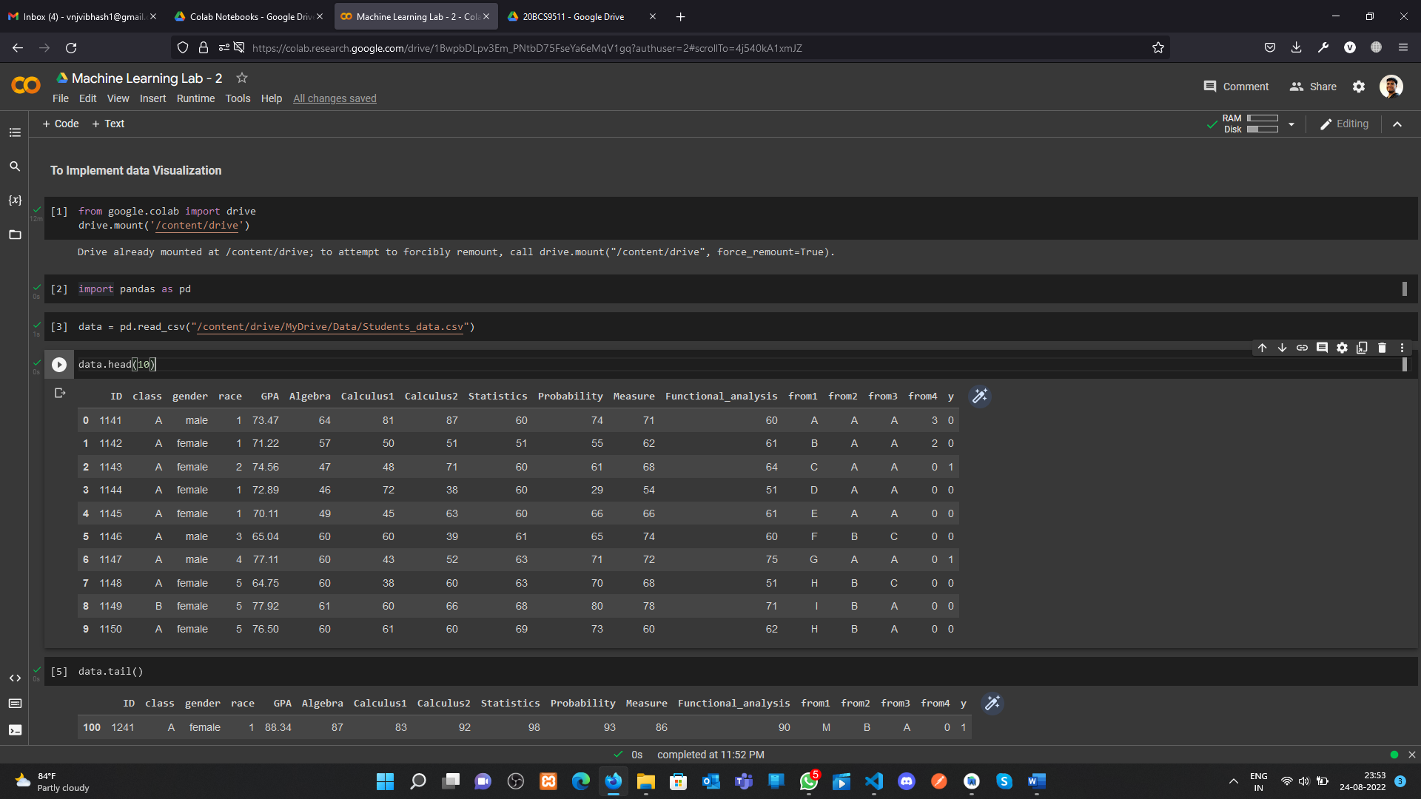

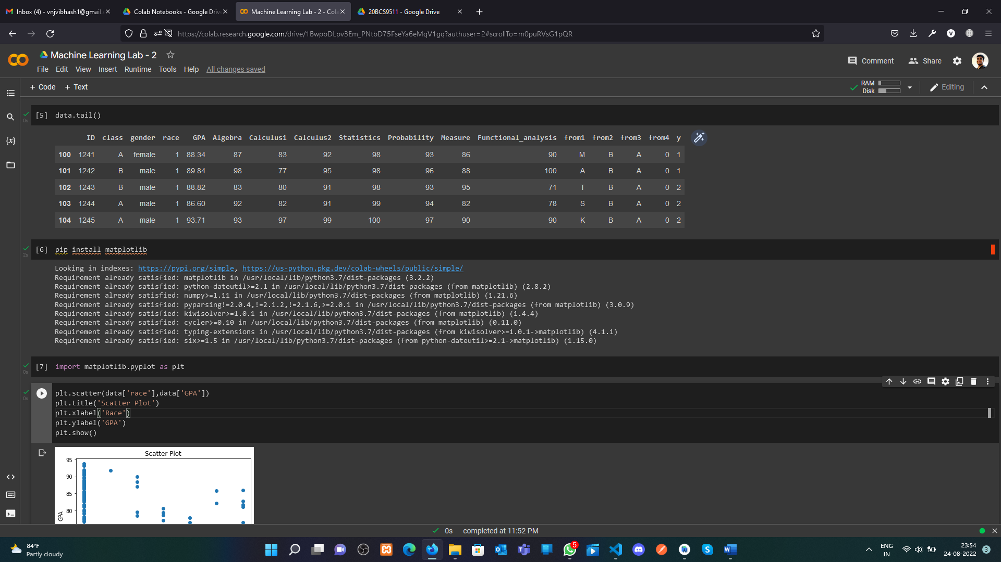

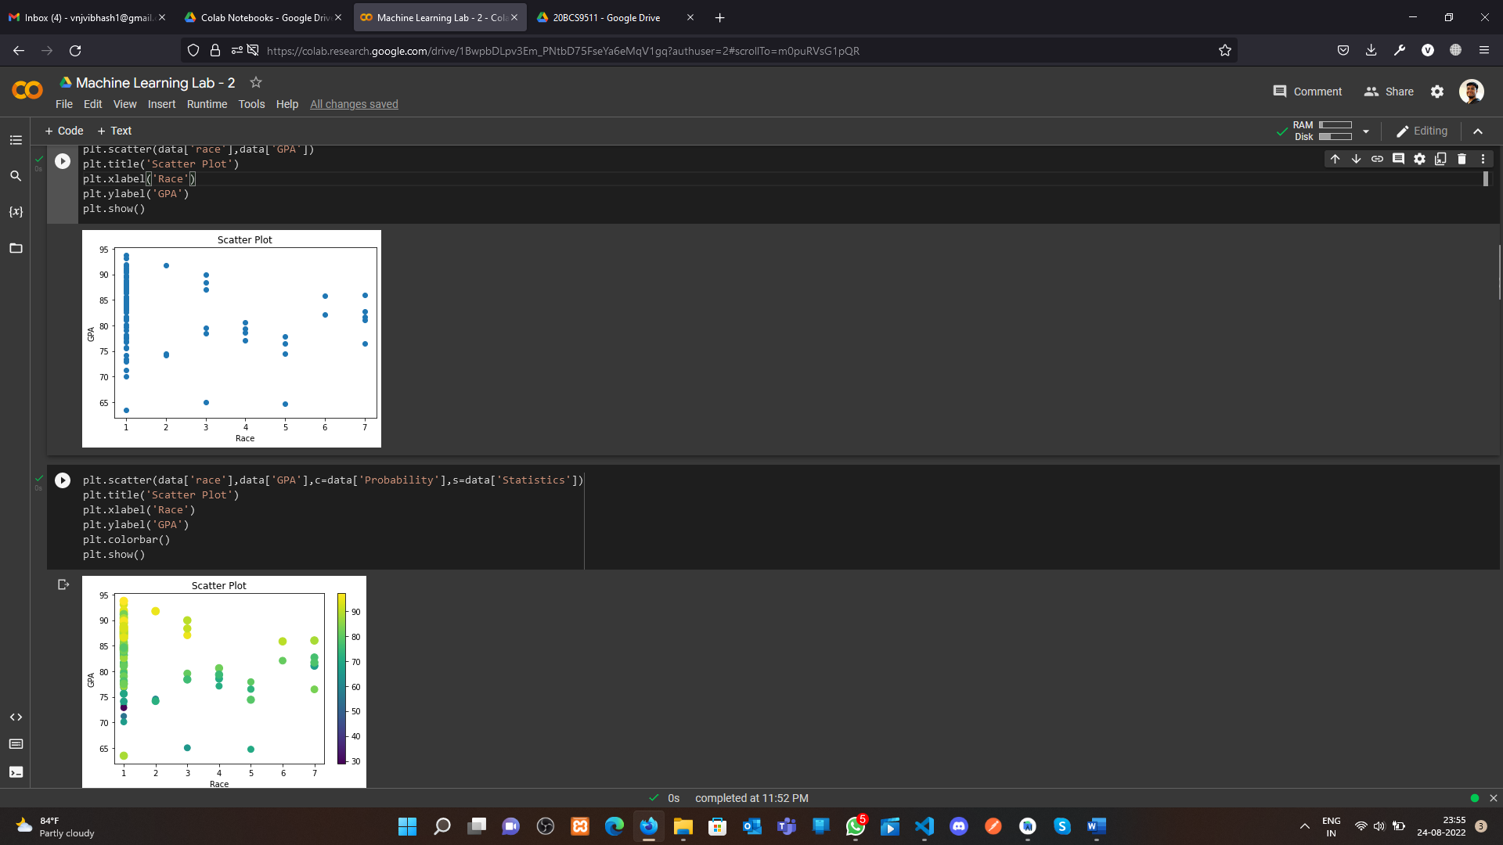

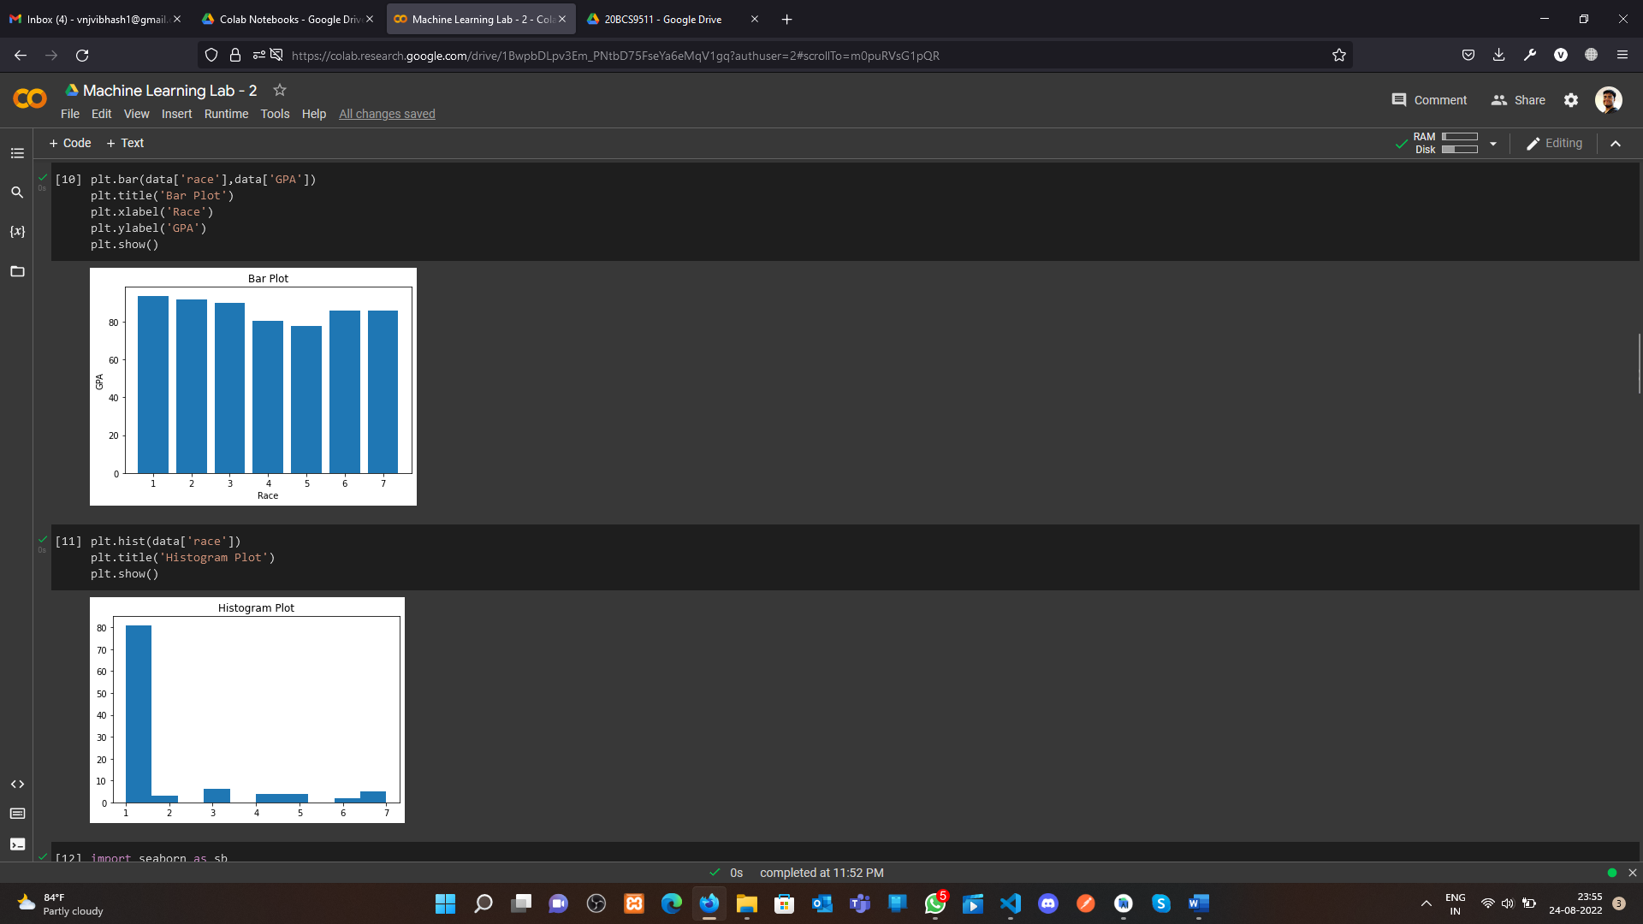

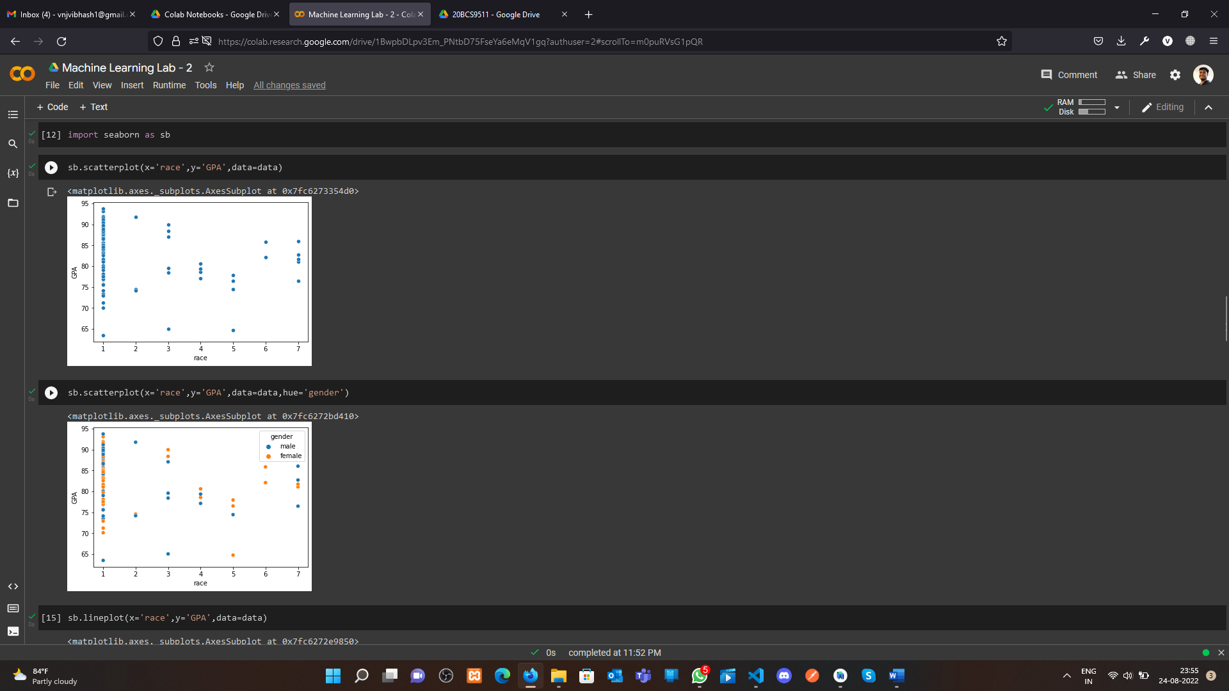

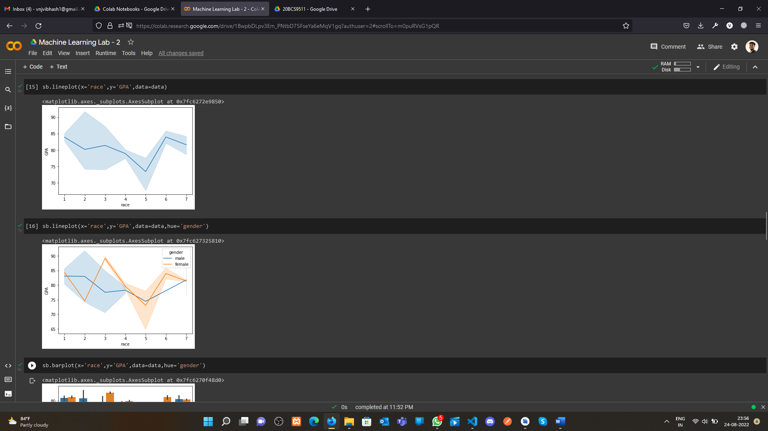

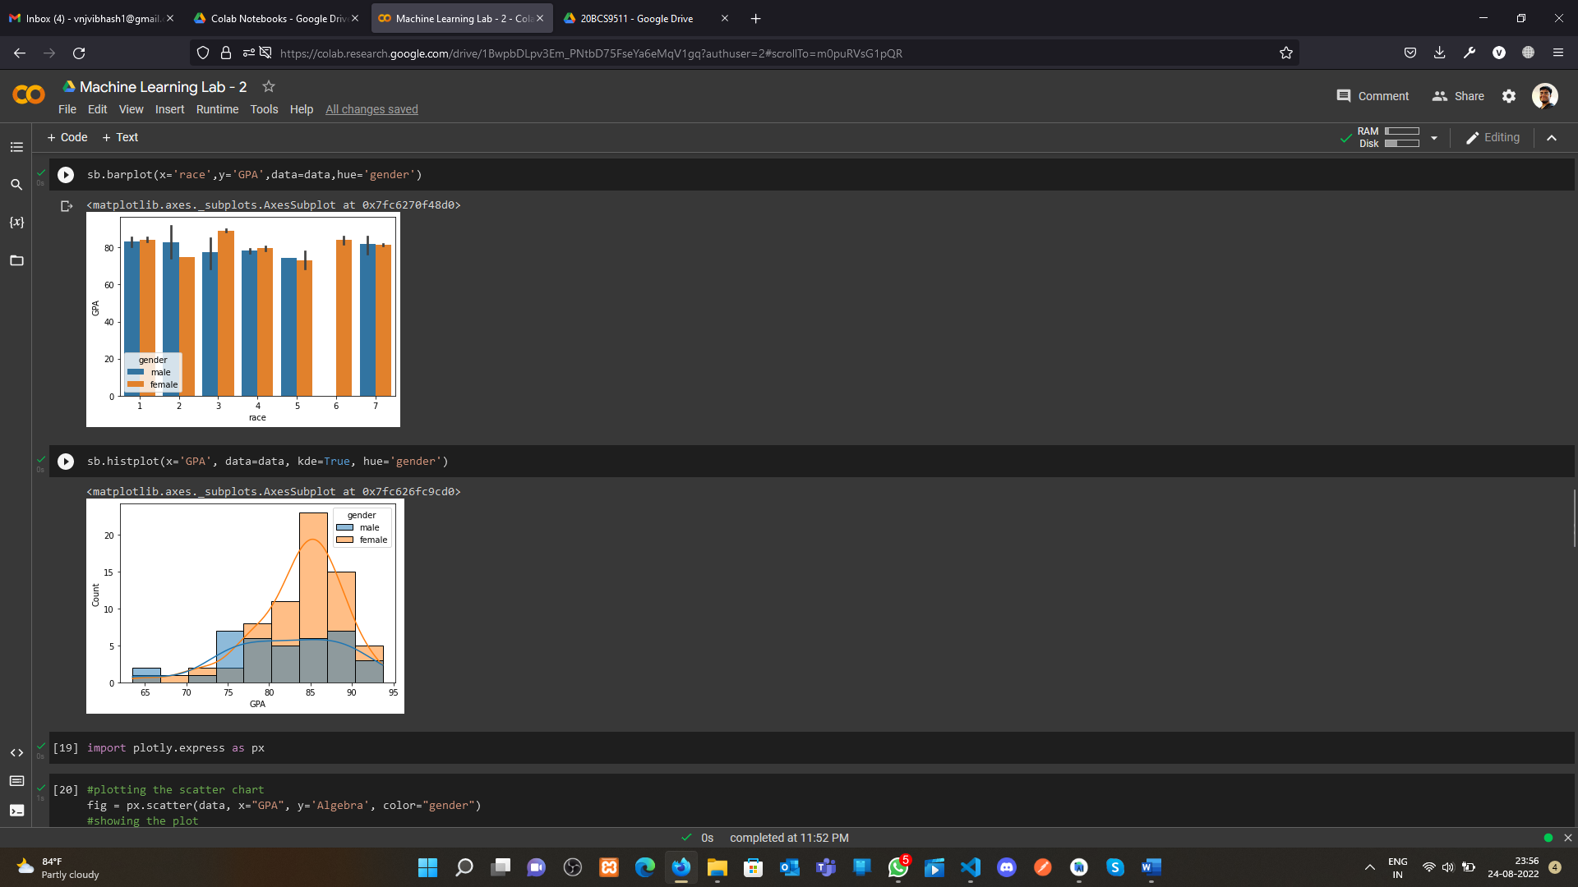

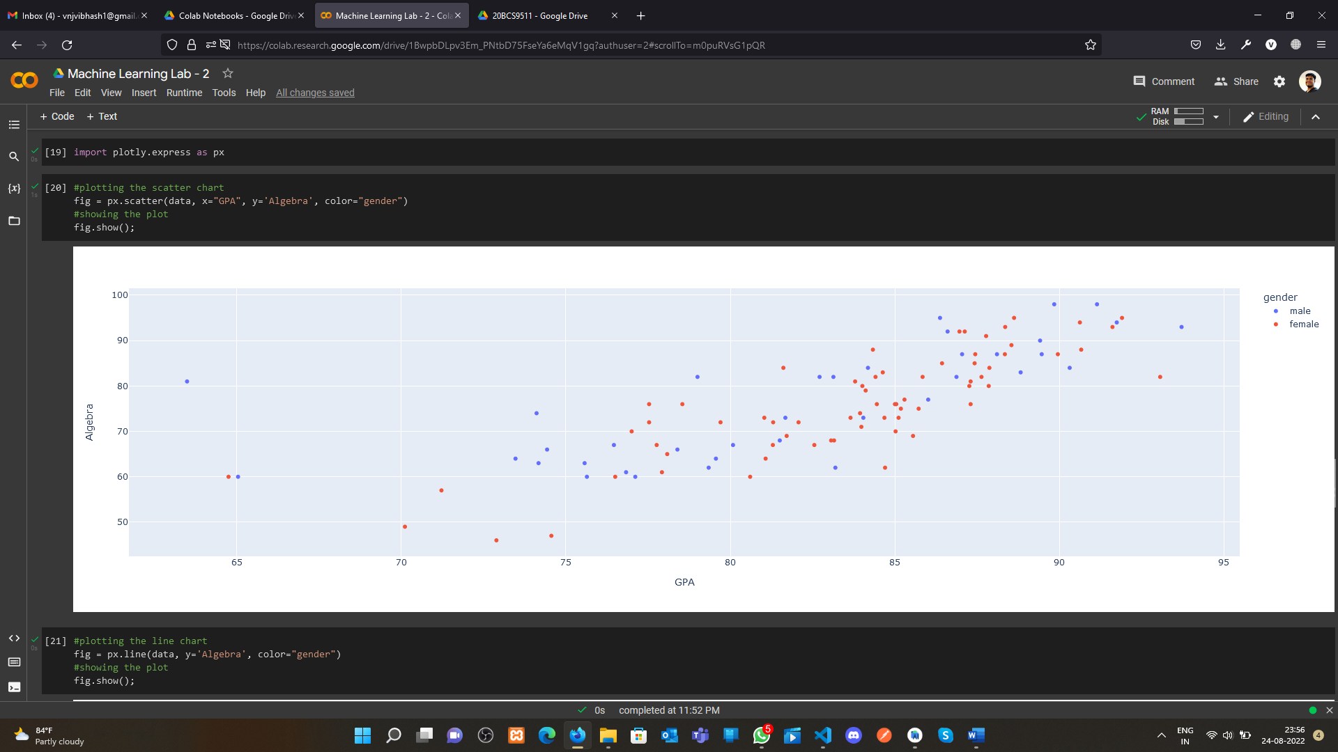

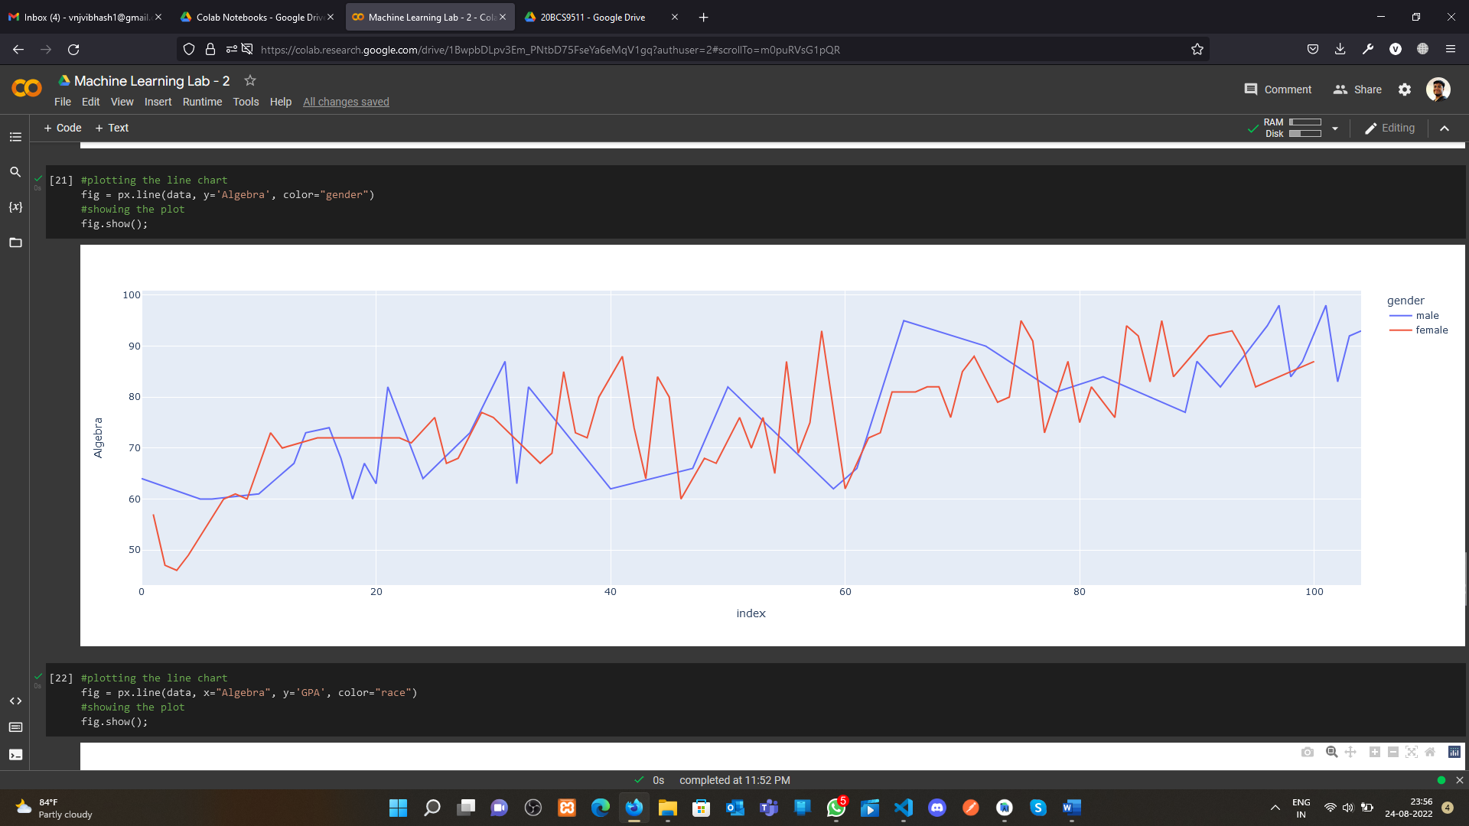

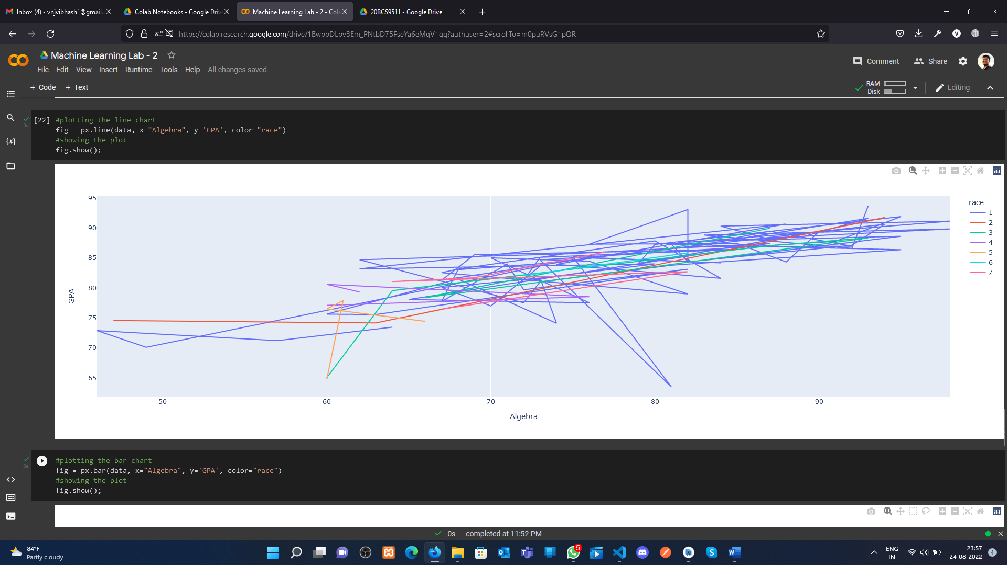

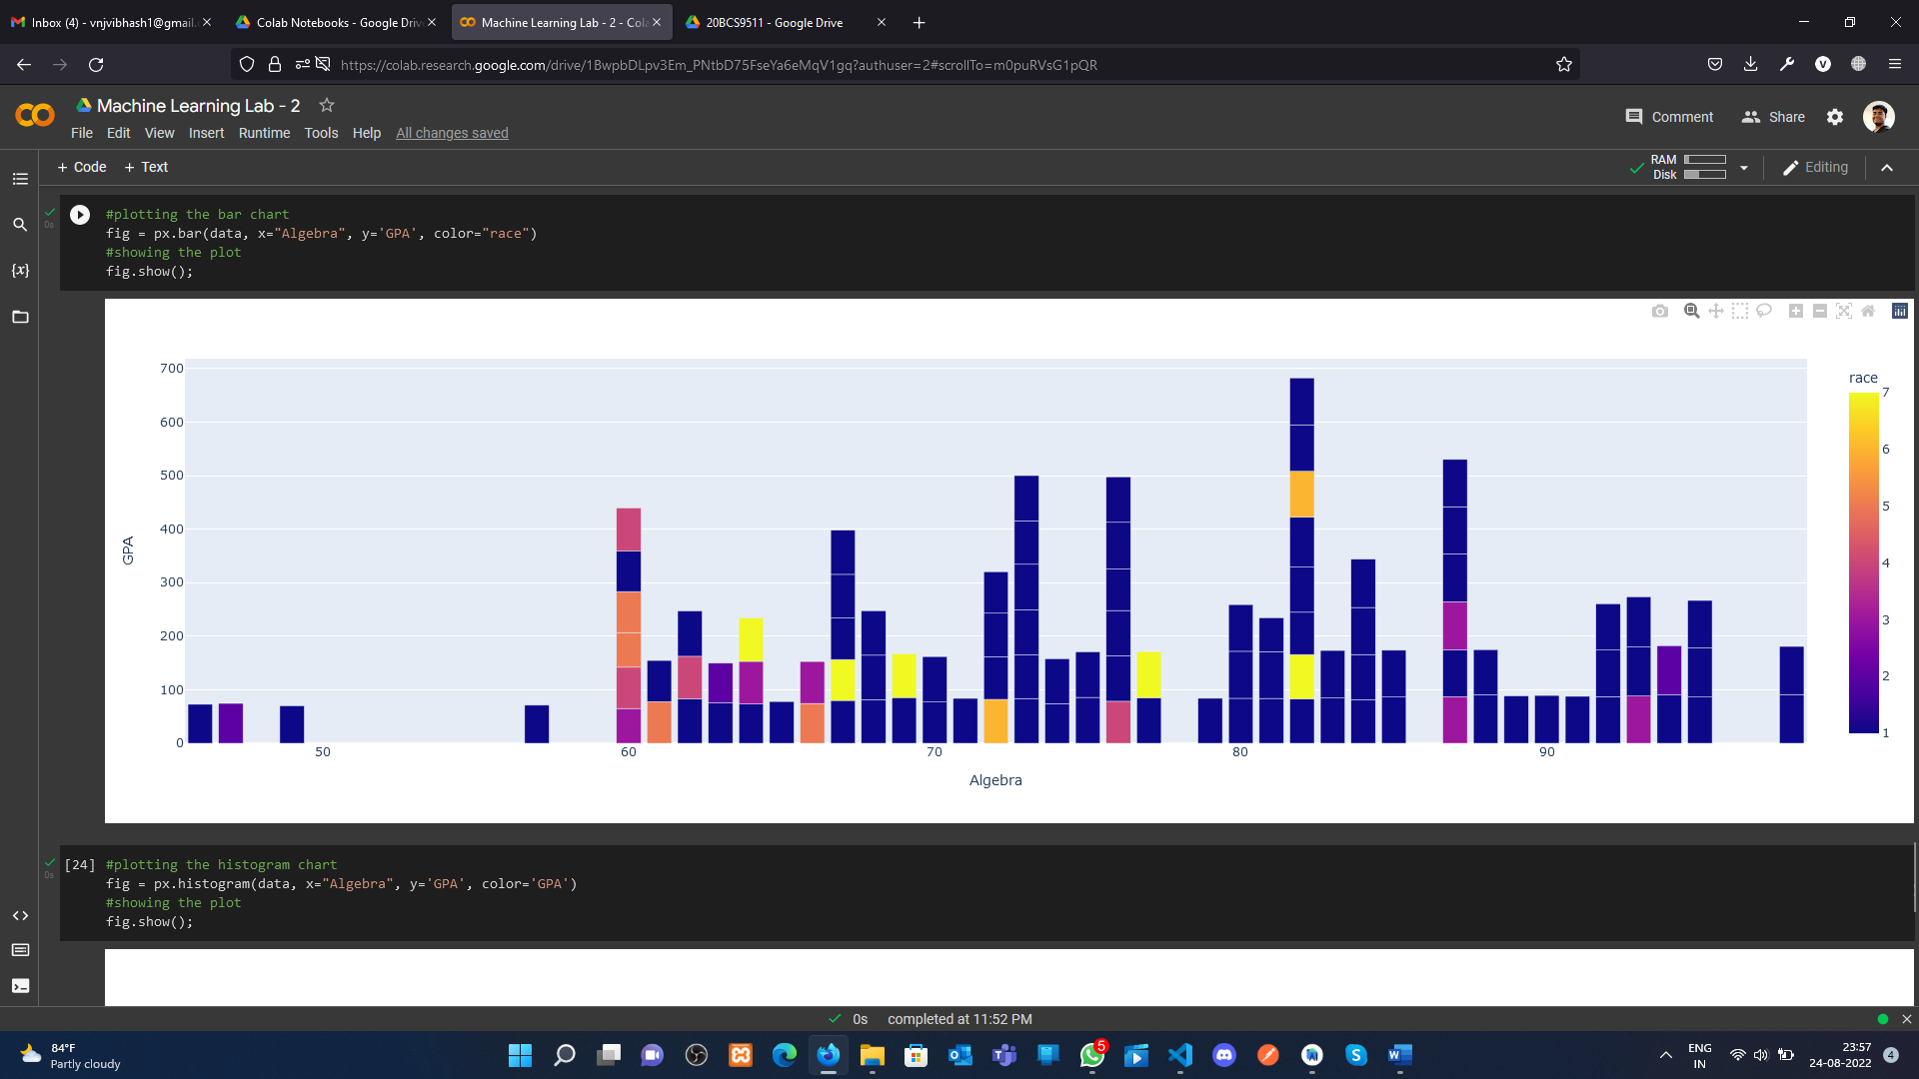

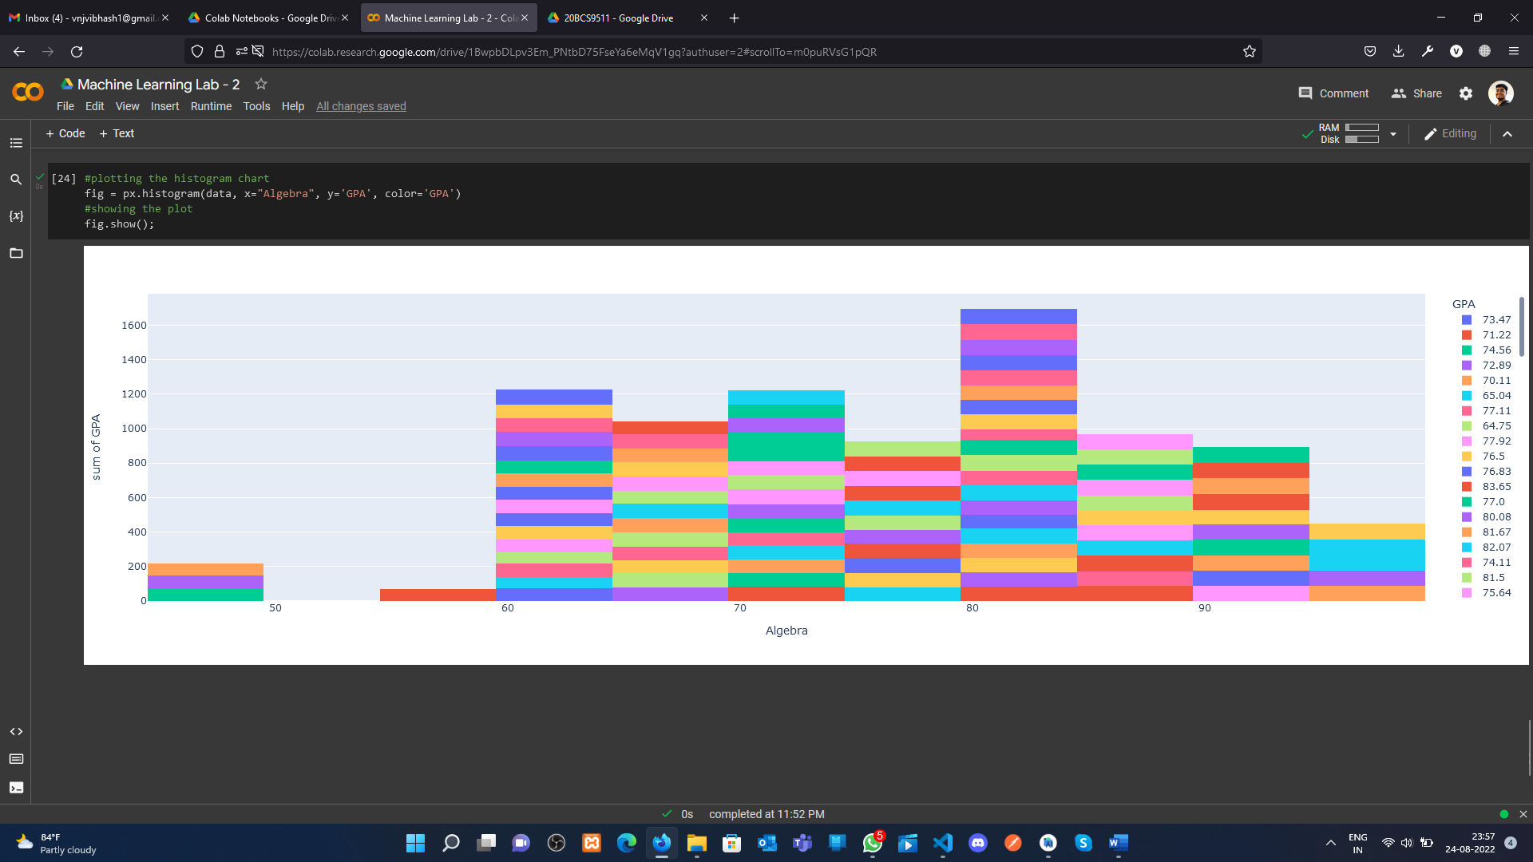

**Learning outcomes (What I have learnt):**

**1.** Data Visualization using matplotlib

**2.** Data visualization using seaborn

**3.** Data Visualization using plotlib

**Evaluation Grid (To be created as per the SOP and Assessment guidelines by the faculty):**

|  |  |  |  |
| --- | --- | --- | --- |
| Sr. No. | Parameters | Marks Obtained | Maximum Marks |
| 1. |  |  |  |
| 2. |  |  |  |
| 3. |  |  |  |
|  |  |  |  |